Week 5 – 8th February 2021 – Senior Infants
ONLINE
 | 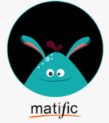 |  | 
WORKBOOKS/TABLE WORK
>Sum Detective p. 40-43 (comparing and ordering) and p.44 (combing/adding)  >Hands on Maths – Sorting a random collection. Sort your toys into groups e.g. teddies group, action figures group, lego group, cars group. EXPLAIN how you sorted the toys/things. Tidy up after! |  | 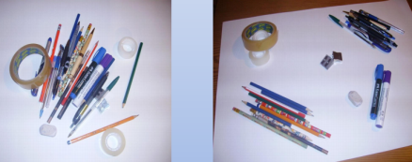 Example of school supplies. You could sort pencil case items for more practice.
>Spellbound - next 2 pages
>Sounds Make Words – next 2 pages
>Handwriting book – 2 pages TAKE YOUR TIME!

>Reading and Rereading – You all got different readers or books and they are all at or around your level. Rereading is reading again. If it’s a short book, reread it each day. If you have a long book you can reread a chapter. Sometimes it might feel a bit boring rereading but it’s an important step in learning to read. Rereading improves these skills - your fluency (how smoothly you read), speed (how quickly you read – not too slow, not too fast), and your comprehension (your understanding of the story). Try to read two books a week. This means reading one book for 2 or 3 days and then reading the next book for 2 or 3 days. Remember to reread.

>Listen to a story - Chat about the characters – Talk about their personality - are they nice, kind, caring, fun, mean, selfish…? Talk about their feelings- are they sad/angry/happy…why? What makes you feel sad/angry? What makes you feel better?
S.E.S.E. lessons – everything you need is on Seesaw. This week:
Science – Animal Babies & Forces – Push and Pull
Geography – Spring is Here!
SPHE – New Life RSE Topic
Information page for parents/guardians on Seesaw.
New Life meditation – see Seesaw for wording
Nature Walk - If possible, go for a walk and look out for Signs of Spring and new life i.e. lambs, shoots, buds on trees, daffodils, snowdrops, crocuses, etc.
Gaeilge –Practice using your phrases with your family. Pronunciation guide and new Bia (food) lessons on Seesaw.

