Week 4 – 1st February 2021 - Senior Infants
There are new activities on Seesaw to complete over the week.


You can post any of the workbook/copy/tablework to your Seesaw journal by clicking the green Add button.
I have some links this week on Seesaw to FolensOnline activities. Make sure to register as a teacher of our school using our school roll number 17796P on www.folensonline.ie/registration. When you’re signing in for the first time click on the Remember Me box and you’ll get in automatically then each time you click on a Folens link on Seesaw.
Workbooks/Table work | Online | Around the house
Sounds Make Words – next 2 pages  Spellbound - next week (2 pages) | -Practice the sounds.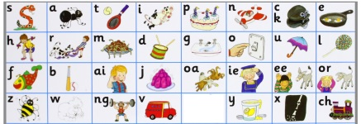 | Listen to a bedtime story or a story anytime! Chat about the ending – how did the characters feel at the end? Was it a good ending? What do you think happens to the characters after the end of the story?
Writing ‘My Teddy Bear’:  Write 3 sentences about your favourite teddy bear e.g. ‘This is my teddy bear. His/Her name is ____.’ What colour is your teddy? When did you get it? Who gave it to you? You might like to draw a picture of your teddy bear or upload a picture of you and your teddy to Seesaw. Do your best writing. | Alphablocks Yellow level 3 episodes 13-14 on YouTube:  https://www.youtube.com/watch?v=MfqlWu1fR_k&list=PLSW2D61TnopRF7ZTjiD4o3so50dyWXwFn&index=5  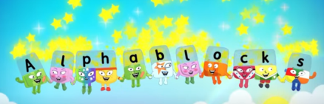  (ar, oi, or, ur sounds) | Wellbeing–  Try out the Teddy Belly Breathing exercise on Seesaw.  PE- Walk, jog, hop and run around your garden.
Maths – p. 5 & 38 (ordering) and  p.39 & 66-69 (0-10) | Play Topmarks Teddy Numbers Game: https://www.topmarks.co.uk/learning-to-count/teddy-numbers  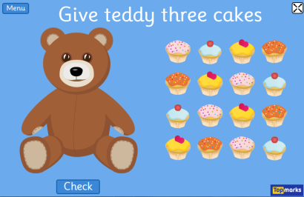  Select numbers to 10 and then words to 10. | Order things in your house by width (start with narrow and getting wider and wider until you get to the widest item)  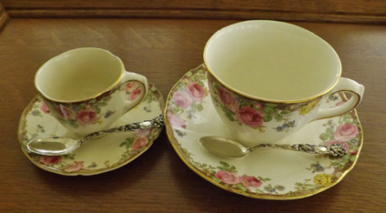
Free-writing – write anything - Praise for effort and ignore mistakes in the free-writing copy. It’s all about building confidence and trying out writing and different writing genres e.g. shopping list, get well card, jokes, song lyrics, labelling drawings of toys, description of their pet, menu to play restaurant at home, etc. | Gaeilge - I have uploaded lessons to Seesaw around the theme of Bia (food).  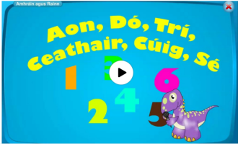  Try to use the simple Sa Chistin phrases at meal times.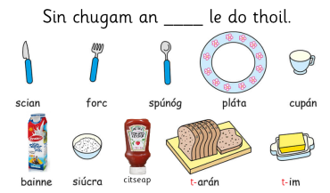 | Gaeilge – Try to use some of these phrases we have looked at already:  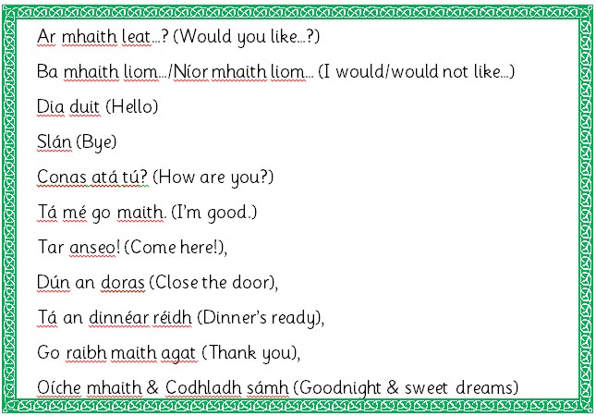

S.E.S.E. lessons – everything you need is on Seesaw. This week:
History – Old and New Toys & Story of the Teddy Bear.
Geography – Play Spaces
Readers – read each day
- Read aloud to your parent readers on www.folensonline.ie . Search ‘Reading Zone’ and select the right class level. There are several readers for each class group. If these books don’t suit your child try an easier/harder level, or if they just don’t like the style of book try out the readers on edcolearning or another source.
- Read aloud to your parent readers on www.edcolearning.ie . Username: edcotrial Password: edcotrial. Search for reader. Click Fit on Screen (bottom right) to enlarge page.
Senior Infants readers - Oh no, Zeb 2012 Book 1 & Danny to the Rescue 2012
- Choose shorter books like we have at school on Oxford Owls e-books library - sign up for free access to high quality levelled readers www.oxfordowl.co.uk/user/sign_up.html
Matific App  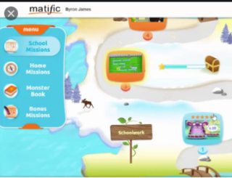  Password: maths | 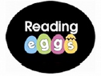  Reading Eggs App  Password: eggs

