Week 4 – 1st February 2021 - Junior Infants
There are new activities on Seesaw to complete over the week.


You can post any of the workbook/copy/tablework to your Seesaw journal by clicking the green Add button.
I have some links this week on Seesaw to FolensOnline activities. Make sure to register as a teacher of our school using our school roll number 17796P on www.folensonline.ie/registration. When you’re signing in for the first time click on the Remember Me box and you’ll get in automatically then each time you click on a Folens link on Seesaw.
Workbooks/Table work | Online |  | Around the house
Sounds Make Words p.62- 63. Watch the sh videos on Seesaw before you begin. You will need your page open and pencil ready. | Our new sound this week is sh. -There are Jolly Phonics lessons on Seesaw. Please view them in order.  -Practice the sounds.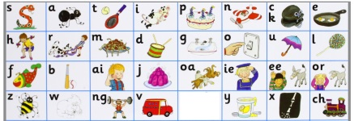  -Ending sounds activity. |  | Listen to a bedtime story or a story anytime! Chat about the ending – how did the characters feel at the end? Was it a good ending? What do you think happens to the characters after the end of the story?
Tricky words are words that we can't really sound out, we just have to see them and say them. There are lots of tricky words in books and stories so they are very important! | Tricky words on Seesaw  - I video  - I activity |  | Wellbeing–  Try out the Teddy Belly Breathing exercise on Seesaw.  PE- Walk, jog, hop and run around your garden.
Handwriting – practice writing words with sh. Parents please write out some simple words with sh e.g. shop, shed, shell, fish.  You can use the words from the Seesaw video if you prefer. Child copies underneath. NB encourage holding pencil correctly. | Have a go of the rhyming activity on Seesaw. If you’re finding this tricky, listen to some traditional nursery rhymes during the week to help you to notice rhyming words. e.g. https://www.youtube.com/watch?v=dhYWxbrUU0w . Other nice channels include Super Simple Songs, Cocomelon, Little Baby Bum. |  | sh search – can you find anything in your house that starts with sh, ends with sh or has sh in the middle? 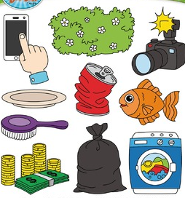
Maths – Number 0  - Count the sounds game – Parent/sibling drops 1, 2, 3 or 4 objects into a tin/box one at a time and child listens and counts how many they heard going in. Take turns.  - Parents call out a number 0-4 and you show the number on your fingers.  - Sum Detective p.60, 61, 63 Numbers 1-4 & p.62 Number 0 | Numberblocks – Zero the Hero! episode on YouTube: https://www.youtube.com/watch?v=Nv1MGOtRpqo  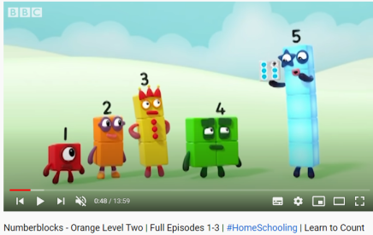  - Zero activity on Seesaw |  | Maths – Sorting by Colour  Can you sort your toys or things in the house by colour? Make 3 or 4 groups (sets/bundles) – one for each colour. Tidy up after!  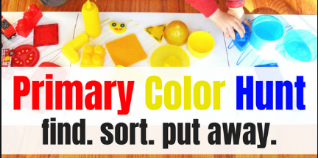
Free-writing – write anything - Praise for effort and ignore mistakes in the free-writing copy. It’s all about building confidence and trying out writing and different writing genres e.g. shopping list, get well card, jokes, song lyrics, labelling drawings of toys, description of their pet, menu to play restaurant at home, etc. | Gaeilge - I have uploaded lessons to Seesaw around the theme of Bia (food).  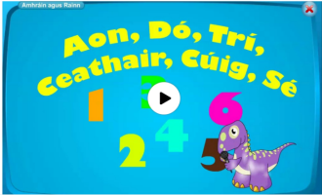  Try to use the simple Sa Chistin phrases at meal times.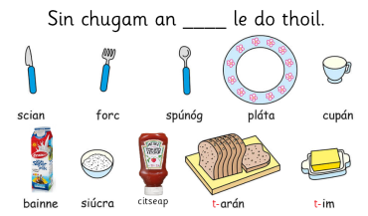 |  | Gaeilge – Try to use some of these phrases we have looked at already:  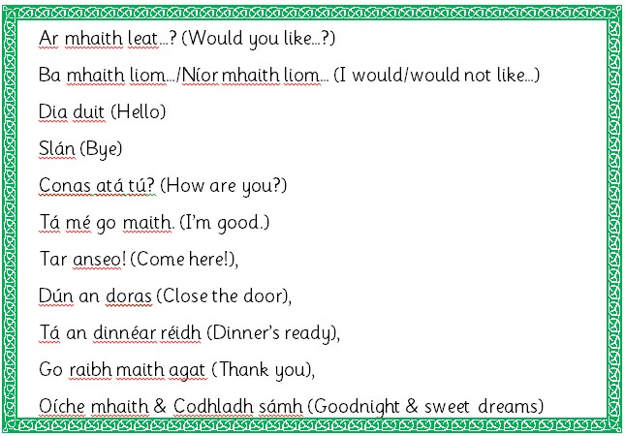
S.E.S.E. lessons – everything you need is on Seesaw. This week:
History – Old and New Toys & Story of the Teddy Bear.
Geography – Play Spaces
Matific App  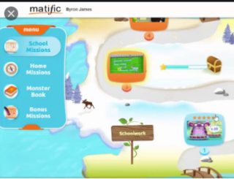  Password: maths |  | 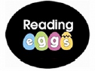  Reading Eggs App  Password: eggs

