Week 4 – 1st February 2021 – 2nd Class
There are new activities on Seesaw to complete over the week.


You can post any of the workbook/copy/tablework to your Seesaw journal by clicking the green Add button.
I have some links this week on Seesaw to FolensOnline activities. Make sure to register as a teacher of our school using our school roll number 17796P on www.folensonline.ie/registration. When you’re signing in for the first time click on the Remember Me box and you’ll get in automatically then each time you click on a Folens link on Seesaw.
Workbooks/Table work | Online |  | Around the house
Spellings for Me –  a week of work (about 4 pages).  Sounds Make Words – next 2 pages | Spellings for Me online activities. Email if you need your log in details. |  | Listen to a bedtime story or a story anytime! Chat about the ending – how did the characters feel at the end? Was it a good ending? What do you think happens to the characters after the end of the story?
Writing ‘My Teddy Bear’:  Write a page about your favourite teddy bear. You could describe him, explain where you got him and why is he special. You might like to draw a picture of your teddy bear or upload a picture of you and your teddy to Seesaw. Do your best joined writing. | Read each day whether online or an actual book. You can send a short recording of you reading if you like. |  | Wellbeing–  Try out the Teddy Belly Breathing exercise on Seesaw.  PE- Walk, jog, hop and run around your garden.
Mental Maths – next week of work (2 pages)  Maths book –  p.59-61 Operations,  and then go back to-  p. 50-51 Money. There is an activity on Edco for p. 50. The link is on Seesaw. | Topmarks Subtraction game:    https://www.topmarks.co.uk/subtraction/subtraction-to-10  Seesaw link for Money p.50 |  | If you have a pack of cards at home ask someone to show you how to play a game like Solitaire (single player) or a game for pairs or groups like Snap, Go Fish, etc.
Free-writing – write anything - Praise for effort and ignore mistakes in the free-writing copy. It’s all about building confidence and trying out writing and different writing genres e.g. shopping list, get well card, jokes, song lyrics, labelling drawings of toys, description of their pet, menu to play restaurant at home, etc. | Gaeilge - I have uploaded lessons to Seesaw around the theme of Bia (food).  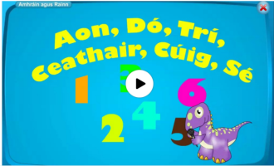  Try to use the simple Sa Chistin phrases at meal times.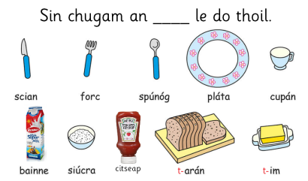  There may be some other Irish activities on Seesaw depending on your class level. |  | Gaeilge – Try to use some of these phrases we have looked at already:  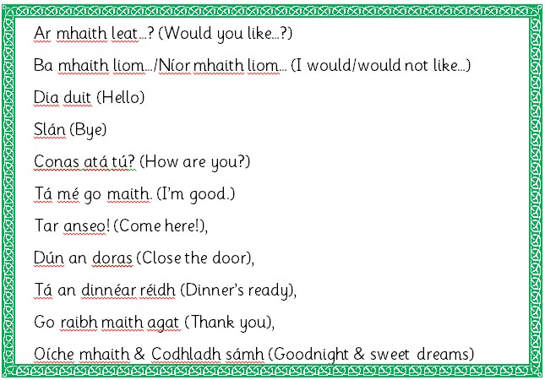
S.E.S.E. lessons – everything you need is on Seesaw. This week:
History – Old and New Toys & Story of the Teddy Bear.
Geography – Toys from Around the World p.38
Readers – read each day
- Read aloud to your parent readers on www.folensonline.ie . Search ‘Reading Zone’ and select the right class level. There are several readers for each class group. If these books don’t suit your child try an easier/harder level, or if they just don’t like the style of book try out the readers on edcolearning or another source.
- Read aloud to your parent readers on www.edcolearning.ie . Username: edcotrial Password: edcotrial. Search for reader. Click Fit on Screen (bottom right) to enlarge page.
1st/2nd class novel (Novel 1) - Jasper Saves the Day 2012
2nd class novel (Novel 2) - Jasper Goes on Holiday 2012
2nd class reading collection (Book 1) - Keep Going and more… 2012
2nd class reading collection (Book 2) - Clickety-click! and more… 2012
- Choose shorter books like we have at school on Oxford Owls e-books library - sign up for free access to high quality levelled readers www.oxfordowl.co.uk/user/sign_up.html
Matific App  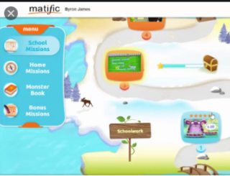  Password: maths |  | 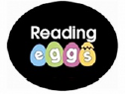  Reading Eggs App  Password: eggs

