Week 3 – 25th – 29th January 2021 - Senior Infants
There are new activities on Seesaw to complete over the week.


You can post any of the workbook/copy/tablework to your Seesaw journal by clicking the green Add button.
I have some links this week on Seesaw to FolensOnline activities. Make sure to register as a teacher of our school using our school roll number 17796P on www.folensonline.ie/registration. When you’re signing in for the first time click on the Remember Me box and you’ll get in automatically then each time you click on a Folens link on Seesaw.
Workbooks/Table work | Online |  | Around the house
Sounds Make words next 2 pages | There are some games on Folens Online to go with Sounds Make Words if you want to try them out. You can filter by letter sound so you can find the games that go with the sounds you are doing in your book. |  | Listen to a bedtime story or a story anytime! Chat about the ending – how did the characters feel at the end? Was it a good ending? What do you think happens to the characters after the end of the story?
Spellbound next week (2 pages) | Alphablocks Yellow level 3 episodes 7-9 on YouTube:  https://www.youtube.com/watch?v=UzuPWBRkCYE&list=PLSW2D61TnopRF7ZTjiD4o3so50dyWXwFn&index=3  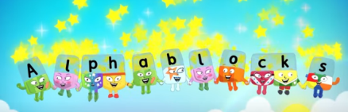  (igh, oa, oo sounds) |  | Wellbeing and PE –  You could go for a walk or play outside. Try our Go Noodle dances or Cosmic Yoga on YouTube.
Handwriting - copy a sentence from a story book into a copy and focus on neat writing (finger space, even size of letters). | Practice the sounds on Seesaw. 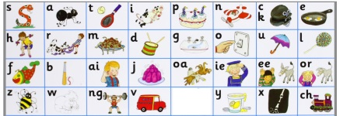 |  | Wellbeing - At bedtime, name a few good things about your day.
Maths – Number 10 activities  Sum Detective p. 34-37 | Play Topmarks Ladybird Game  https://www.topmarks.co.uk/learning-to-count/ladybird-spots  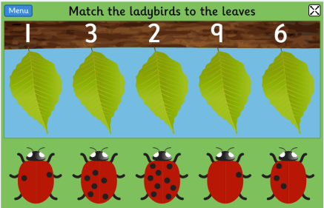  Select counting, matching and ordering to 10 games. |  | Maths – Number 10  Find all the ways to make 10 with household items (crayons, lego, toy cars…)  e.g. 1+9=10, 2+8=10, …  Say the number sentence aloud each time and write it in your copy like this 0+10=10.  See the number 6 example on Seesaw if you’re not sure.
Free-writing – write anything – write letters they know, copy words from around the room/cupboards, write their own name, try writing simple words. Praise for effort and ignore mistakes in the free-writing copy. It’s all about building confidence and trying out writing and different writing genres e.g. shopping list, get well card, jokes, song lyrics, labelling drawings of toys, description of their pet, menu to play restaurant at home, etc. | Gaeilge - Seesaw.  I will have some of the Folens Online Irish activity links on Seesaw to help you navigate your way through the Sa Bhaile theme in Abair Liom. There may be some other Irish activities on Seesaw depending on your class level. |  | Gaeilge – Try to use some of these phrases at home this week:  Ar mhaith leat…? (Would you like…?)  Ba mhaith liom…/Níor mhaith liom… (I would/would not like…)  Dia duit (Hello)  Slán (Bye)  Conas atá tú? (How are you?)  Tá mé go maith. (I’m good.)  Tar anseo! (Come here!),  Dún an doras (Close the door),  Tá an dinnéar réidh (Dinner’s ready),  Go raibh maith agat (Thank you),  Oíche mhaith & Codhladh sámh (Goodnight & sweet dreams)
Readers – read each day
- Read aloud to your parent readers on www.folensonline.ie . Search ‘Reading Zone’ and select the right class level. There are several readers for each class group. If these books don’t suit your child try an easier/harder level, or if they just don’t like the style of book try out the readers on edcolearning or another source.
- Read aloud to your parent readers on www.edcolearning.ie . Username: edcotrial Password: edcotrial. Search for reader. Click Fit on Screen (bottom right) to enlarge page.
Senior Infants readers - Oh no, Zeb 2012 Book 1 & Danny to the Rescue 2012
- Choose shorter books like we have at school on Oxford Owls e-books library - sign up for free access to high quality levelled readers www.oxfordowl.co.uk/user/sign_up.html
Geography – The Park Ranger p. 44 lesson - Edco Learning - www.edcolearning.ie
Username: edcotrial Password: edcotrial.
- Use the Seesaw link to get started. Click on the Audio link on p.44 to hear the Park Ranger talking about his work. Parent can read this aloud if you prefer.
- Use a local park or garden as a starting point for discussion e.g. Altamont, Kilkenny Castle Park. Ask the children if they have ever visited it and talk about what they saw or did there. Ask the children to think about who takes care of the park. Someone may suggest a park ranger/keeper.
- Listen to the park ranger talking about his job as a park ranger on the audio clip or read text below. Discuss the work he does in the park. Ask the children to think about why it is important to have people who take care of our parks and green areas.
- Pupil Book, page 44: The Park Ranger. The children read about Kieron’s job as a park ranger and complete the fact file. Infants can do this orally.
- Think like a Geographer! Ask children -
• Where does Kieron work?
• What does Kieron do in the park?
• How does a park ranger help in the community?
• What would happen if we did not have park rangers to take care of our parks?
SPHE/Art – The Park
Design an anti-litter poster to remind people to keep your local park clean OR a poster to encourage people to pick up their dog’s poo when out walking.
Matific App  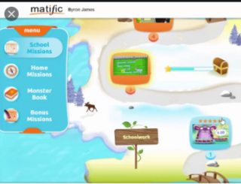  Password: maths |  |   Reading Eggs App  Password: eggs

