Week 3 – 25th – 29th January 2021 - Junior Infants
There are new activities on Seesaw to complete over the week.


You can post any of the workbook/copy/tablework to your Seesaw journal by clicking the green Add button.
I have some links this week on Seesaw to FolensOnline activities. Make sure to register as a teacher of our school using our school roll number 17796P on www.folensonline.ie/registration. When you’re signing in for the first time click on the Remember Me box and you’ll get in automatically then each time you click on a Folens link on Seesaw.
Workbooks/Table work | Online |  | Around the house
Sounds Make Words p.59. Watch the ch videos on Seesaw before you begin. You will need your page open and pencil ready. If your child is getting tired, try and get half done and then come back to it later. This will be easier for some children than others. We all learn at different paces. | Our new sound this week is ch. -There are two Jolly Phonics lessons on Seesaw.  -Introduction video for Sounds Make Words p.59 |  | Listen to a bedtime story or a story anytime! Chat about the ending – how did the characters feel at the end? Was it a good ending? What do you think happens to the characters after the end of the story?
Sounds Make Words p.60 ‘ch’ sound. Check pencil grip and that they are writing the letter correctly. Some might need to trace the x at the bottom of the page.  Sounds Make Words p.61 Child tries to read the questions and answer. You may need to prompt them to sound out each sound and say the word, one at a time, and then put the words together faster so they understand the question. | Practice the sounds on Seesaw.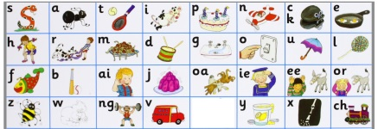 |  | Wellbeing and PE –  You could go for a walk or play outside. Try our Go Noodle dances or Cosmic Yoga on YouTube.  Wellbeing - At bedtime, name a few good things about your day.
Handwriting – practice writing words with ch. Parents please write out some simple words with ch e.g. lunch, chick, chair, crunch. You can use the words from the Seesaw video if you prefer. Child copies underneath. Encourage holding pencil correctly, sitting in to the table, their other hand on page, taking their time to copy carefully. Praise for good effort. | Have a go of the rhyming activity on Seesaw. If you’re finding this tricky, listen to some traditional nursery rhymes during the week to help you to notice rhyming words. e.g. https://www.youtube.com/watch?v=dhYWxbrUU0w . Other nice channels include Super Simple Songs, Cocomelon, Little Baby Bum. |  | Ch search – can you find anything in your house beginning with ch? The kitchen is a good place to look. You might find some of these…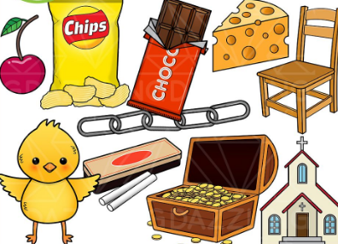
Maths – Number 3 and 4  - Count the sounds game – Parent/sibling drops 1, 2, 3 or 4 objects into a tin/box one at a time and child listens and counts how many they heard going in. Take turns.  - Parents call out a number 1-4 and you show the number on your fingers.  - Sum Detective p. 54-55 Number 4 and p.58-59 Numbers 1-4 | Numberblocks Number 4 episodes on YouTube: https://www.youtube.com/watch?v=Xket7YPSCYk 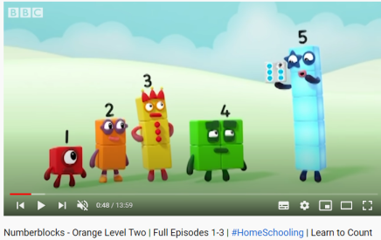  Maths activity on Seesaw. |  | Maths – Ordering by Size  Gather up some toys and then put them in a line by size, starting with the smallest and getting bigger and bigger until you get to the biggest one. You can then do this activity with other objects around the house – maybe your families shoes/socks, spoons, etc. 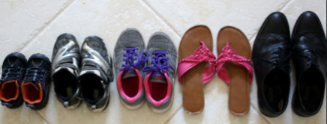  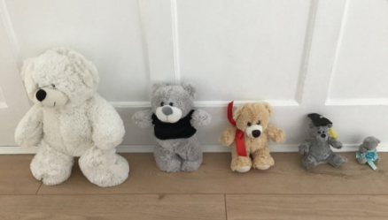
Free-writing – write anything – write letters they know, copy words from around the room/cupboards, write their own name, try writing simple words. Praise for effort and ignore mistakes in the free-writing copy. It’s all about building confidence and trying out writing and different writing genres e.g. shopping list, get well card, jokes, song lyrics, labelling drawings of toys, description of their pet, menu to play restaurant at home, etc. | Gaeilge - Seesaw.  I will have some of the Folens Online Irish activity links on Seesaw to help you navigate your way through the Sa Bhaile theme in Abair Liom. There may be some other Irish activities on Seesaw depending on your class level. |  | Gaeilge – Try to use some of these phrases at home this week:  Ar mhaith leat…? (Would you like…?)  Ba mhaith liom…/Níor mhaith liom… (I would/would not like…)  Dia duit (Hello)  Slán (Bye)  Conas atá tú? (How are you?)  Tá mé go maith. (I’m good.)  Tar anseo! (Come here!),  Dún an doras (Close the door),  Tá an dinnéar réidh (Dinner’s ready),  Go raibh maith agat (Thank you),  Oíche mhaith & Codhladh sámh (Goodnight & sweet dreams)
Geography – The Park Ranger p. 44 lesson - Edco Learning - www.edcolearning.ie
Username: edcotrial Password: edcotrial.
- Use the Seesaw link to get started. Click on the Audio link on p.44 to hear the Park Ranger talking about his work. Parent can read this aloud if you prefer.
- Use a local park or garden as a starting point for discussion e.g. Altamont, Kilkenny Castle Park. Ask the children if they have ever visited it and talk about what they saw or did there. Ask the children to think about who takes care of the park. Someone may suggest a park ranger/keeper.
- Listen to the park ranger talking about his job as a park ranger on the audio clip or read text below. Discuss the work he does in the park. Ask the children to think about why it is important to have people who take care of our parks and green areas.
- Pupil Book, page 44: The Park Ranger. The children read about Kieron’s job as a park ranger and complete the fact file. Infants can do this orally.
- Think like a Geographer! Ask children -
• Where does Kieron work?
• What does Kieron do in the park?
• How does a park ranger help in the community?
• What would happen if we did not have park rangers to take care of our parks?
SPHE/Art – The Park
Design an anti-litter poster to remind people to keep your local park clean OR a poster to encourage people to pick up their dog’s poo when out walking.
Matific App  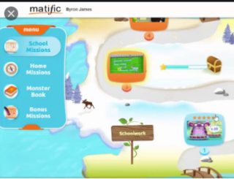  Password: maths |  |   Reading Eggs App  Password: eggs

