Week 2 – 18th – 22nd January 2021 – Senior Infants
There are new activities on Seesaw to complete over the week.


You can post any of the workbook/copy/tablework to your Seesaw journal by clicking the green Add button.
I have some links this week on Seesaw to FolensOnline activities. Make sure to register as a teacher of our school using our school roll number 17796P on www.folensonline.ie/registration. When you’re signing in for the first time click on the Remember Me box and you’ll get in automatically then each time you click on a Folens link on Seesaw.
Workbooks/Table work | Online | Around the house
Sounds Make words next 2 pages | There are some games on Folens Online to go with Sounds Make Words if you want to try them out. You can filter by letter sound so you can find the games that go with the sounds you are doing in your book. | Listen to a bedtime story or a story anytime! It’s valuable quality time, de-stressing and great for their reading skills to cuddle up with a family member and listen to their story.
Spellbound next week (2 pages) | Alphablocks Yellow level 3 episodes 4-6 on YouTube:  https://www.youtube.com/watch?v=Wp3va0hNI4w&list=PLSW2D61TnopRF7ZTjiD4o3so50dyWXwFn&index=2  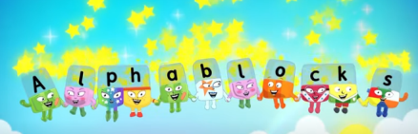  (revising ai and ee) | Wellbeing -  You could do something during the day that relaxes you like Cosmic Yoga, colouring, singing, dancing, balloon breathing, etc.  At bedtime, name a few good things about your day. Maybe you had a nice dinner, or you played a game. It could be that someone did something nice for you or said something kind.
Maths – Number 9 activities  Sum Detective p. 30-33 | Numberblocks – Orange Level 2 episodes 4-6 video on YouTube:  https://www.youtube.com/watch?v=WmOenBwXdw4&list=PL9swKX1PviEor1JJ9oiJwidaT-q69tYW2&index=2  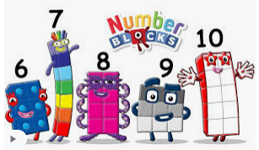  (exploring numbers 9, 10 and adding on 1) | Maths – Number 9  Find all the ways to make 9 with household items (crayons, lego, toy cars…)  e.g. 1+8=9, 2+7=9, …  Say the number sentence aloud each time and write it in your copy like this 0+8=9.  See the number 6 example on Seesaw if you’re not sure.
Handwriting - copy a sentence from a story book into a copy and focus on neat writing (finger space, even size of letters). | Gaeilge - Seesaw.  I will have some of the Folens Online Irish activity links on Seesaw to help you navigate your way through the Sa Bhaile theme in Abair Liom. There may be some other Irish activities on Seesaw depending on your class level. | Gaeilge – Try to use some of these phrases at home this week:  Dia duit (Hello)  Slán (Bye)  Conas atá tú? (How are you?)  Tá mé go maith. (I’m good.)  Tar anseo! (Come here!),  Dún an doras (Close the door),  Tá an dinnéar réidh (Dinner’s ready),  Go raibh maith agat (Thank you),  Oíche mhaith & Codhladh sámh (Goodnight & sweet dreams),
Readers – read each day
- Read aloud to your parent readers on www.folensonline.ie . Search ‘Reading Zone’ and select the right class level. There are several readers for each class group. If these books don’t suit your child try an easier/harder level, or if they just don’t like the style of book try out the readers on edcolearning or another source.
- Read aloud to your parent readers on www.edcolearning.ie . Username: edcotrial Password: edcotrial. Search for reader. Click Fit on Screen (bottom right) to enlarge page.
Senior Infants readers - Oh no, Zeb 2012 Book 1 & Danny to the Rescue 2012
- Choose shorter books like we have at school on Oxford Owls e-books library - sign up for free access to high quality levelled readers www.oxfordowl.co.uk/user/sign_up.html
History – Games from the Past p. 39 lesson - Edco Learning - www.edcolearning.ie
Username: edcotrial Password: edcotrial.
- Once you are logged in, select SESE in subject bar and find ‘Explore with Me 1 2019’. Click on the book image to access the digital workbook. Find Chapter 5 Play. At the top of most pages is a link button to a video/quiz/audio clip. Use these alongside the workbook pages.
- Ask the children to name and describe some of their favourite games.
- Encourage them to consider whether their parents and grandparents would have played these games when they were young and why they think so.
- Look at the slideshow video www.edcolearning.ie . Talk about the different games. Encourage the children to guess or describe the game. Talk to your child about any of the games shown that you played as a child. Describe the games.
- Pupil Book, page 39: Games from the Past. The children talk about the games shown in the photographs, record information about a game from the past and draw a picture of it.
- Think like an Historian! Ask the children these questions:
- Name a game from the past. Is this game still played today? Why / Why not?
- Why do you think children tend to play different games today?
- Name a game that your parents played that is still played today.

PE – Games from the Past
Go and play a game your parent played as a child e.g. Tip the can, Kerbs, Musical Chairs, etc!

Oral Language - Interview – A Favourite Childhood Game.
Phone an older relative about their favourite childhood game. 1st and 2nd write their questions and answers and draw a picture of the game in your SESE/English/free-writing copy. Infants just do this orally (and draw if you wish).
Matific App
Password: maths

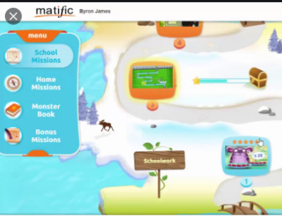
We have set up a 30 day trial of the Matific Student App. This can be played on tablet/phone/computer. It is similar to Manga High but more fun and child friendly. They can complete the games assigned and access the full course too. Your log in was sent to your email.

Reading Eggs App
Password: eggs

We have a 30 day trial of the Reading Eggs App. This can be played on tablet/phone/computer. Your log in was sent to your email.

