Week 2 – 18th – 22nd January 2021 - Junior Infants
There are new activities on Seesaw to complete over the week.


You can post any of the workbook/copy/tablework to your Seesaw journal by clicking the green Add button.
I have some links this week on Seesaw to FolensOnline activities. Make sure to register as a teacher of our school using our school roll number 17796P on www.folensonline.ie/registration. When you’re signing in for the first time click on the Remember Me box and you’ll get in automatically then each time you click on a Folens link on Seesaw.
Workbooks/Table work | Online | Around the house
Sounds Make Words p. 55 add the missing middle sound and read words again over the week. You could hide the pictures to see if they can read the words after. | Our new sound this week is x. We usually hear x at the end or middle of words. 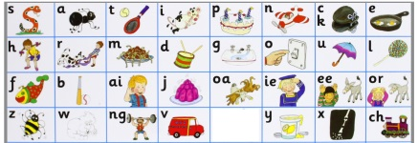  Practice the sounds on Seesaw. | Listen to a bedtime story or a story anytime! Chat about the pictures and what’s happening in the story. Can you guess what will happen next?
Sounds make words p. 57 x sound as in ‘kss’ at the end of words. Check pencil grip and that they are writing the letter correctly. Some might need to trace the x at the bottom of the page. | Learn letter x with the Alphablocks Magic Words:  https://www.youtube.com/watch?v=_O5-M_QMwrE  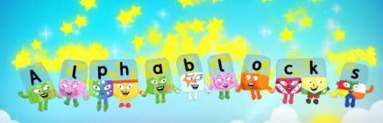 | Wellbeing and PE -  Try our Go Noodle or Cosmic Yoga on YouTube.  Wellbeing - At bedtime, name a few good things about your day.
Handwriting – practice writing words with x. Parents please write out some simple words with x e.g. fox, six, box, fix, mix. Child copies underneath. Encourage holding pencil correctly, sitting in to the table, their other hand on page, taking their time to copy carefully. Praise for good effort. | Here is an Alphablocks story with w and x:  https://www.youtube.com/watch?v=aPNB8UA655k | Play pirates - make a treasure map of a big room in your house. Write out your ‘x’ words on pieces of paper. Hide them around the room and mark x on your map for each word. X marks the spot where your word is. See if your pirate sister/brother/mam/dad can find the treasure. They could make a map for you too.
Maths – Number 3 and 4  - Count numbers 3 and 4 on your fingers.  - Parents call out a number 1-4 and you show the number on your fingers.  - Make the numbers 3 and 4 out of playdoh/dry cereal/pasta shapes.  - Trace the numbers in sand/flour/the ground/rice/…  - Practice writing numbers 3 and 4 on a page/copy. If you have your maths book at home you can do a page each of tracing 3 and 4.  - Sum Detective p. 52-53 Number 4 | Numberblocks - Red Level One full episodes 4-6 on Youtube:  https://www.youtube.com/watch?v=IgFpwMNTFxI&list=PL9swKX1PviEpYtgsxNhSuiqvAsYhc_Uwz&index=2  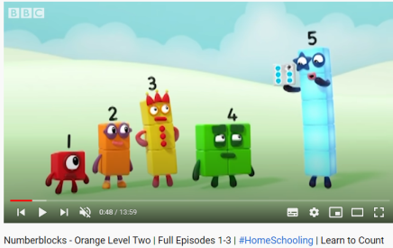  (Exploring numbers 3 and 4) | Maths - Sorting - Gather together some things that are similar and sort into groups. For example gather fruit and sort into 3 groups- oranges, bananas and apples. Or take cutlery and sort into forks, big spoons and small spoons. Or take clothes that are finished in the tumble dryer/clothes line and sort into a pile for each family member or sort by type of clothing i.e. all socks together, all tops etc.  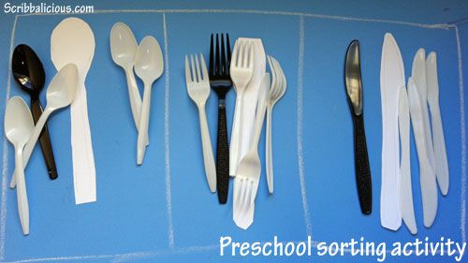

Free-writing – write anything – write letters they know, copy words from around the room/cupboards, write their own name, try writing simple words. Praise for effort and ignore mistakes in the free-writing copy. It’s all about building confidence and trying out writing and different writing genres e.g. shopping list, get well card, jokes, song lyrics, labelling drawings of toys, description of their pet, menu to play restaurant at home, etc. | Gaeilge - Seesaw.  I will have some of the Folens Online Irish activity links on Seesaw to help you navigate your way through the Sa Bhaile theme in Abair Liom. There may be some other Irish activities on Seesaw depending on your class level. | Gaeilge – Try to use some of these phrases at home this week:  Dia duit (Hello)  Slán (Bye)  Conas atá tú? (How are you?)  Tá mé go maith. (I’m good.)  Tar anseo! (Come here!),  Dún an doras (Close the door),  Tá an dinnéar réidh (Dinner’s ready),  Go raibh maith agat (Thank you),  Oíche mhaith & Codhladh sámh (Goodnight & sweet dreams),
History – Games from the Past p. 39 lesson - Edco Learning - www.edcolearning.ie
Username: edcotrial Password: edcotrial.
- Once you are logged in, select SESE in subject bar and find ‘Explore with Me 1 2019’. Click on the book image to access the digital workbook. Find Chapter 5 Play. At the top of most pages is a link button to a video/quiz/audio clip. Use these alongside the workbook pages.
- Ask the children to name and describe some of their favourite games.
- Encourage them to consider whether their parents and grandparents would have played these games when they were young and why they think so.
- Look at the slideshow video www.edcolearning.ie . Talk about the different games. Encourage the children to guess or describe the game. Talk to your child about any of the games shown that you played as a child. Describe the games.
- Pupil Book, page 39: Games from the Past. The children talk about the games shown in the photographs, record information about a game from the past and draw a picture of it.
- Think like an Historian! Ask the children these questions:
- Name a game from the past. Is this game still played today? Why / Why not?
- Why do you think children tend to play different games today?
- Name a game that your parents played that is still played today.

PE – Games from the Past
Go and play a game your parent played as a child e.g. Tip the can, Kerbs, Musical Chairs, etc!

Oral Language - Interview – A Favourite Childhood Game.
Phone an older relative about their favourite childhood game. 1st and 2nd write their questions and answers and draw a picture of the game in your SESE/English/free-writing copy. Infants just do this orally (and draw if you wish).
Matific App
Password: maths

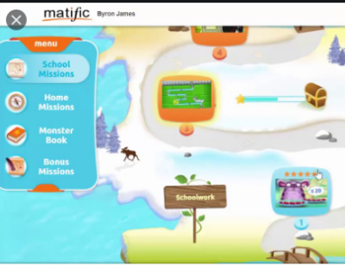
We have set up a 30 day trial of the Matific Student App. This can be played on tablet/phone/computer. It is similar to Manga High but more fun and child friendly. They can complete the games assigned and access the full course too. Your log in was sent to your email.

Reading Eggs App
Password: eggs

We have a 30 day trial of the Reading Eggs App. This can be played on tablet/phone/computer. Your log in was sent to your email.

