Week 1 – 11th -15th January 2021 - Junior Infants
Workbooks/Table work | Online | Around the house
Sounds Make Words p. 52 Show your child how to pick a letter from the top and see if it makes a word with the endings underneath. Get them to try sounding the word out with you and if it is a real word they write in the letter. This page can be used again in the week to practice blending (reading). | Listen to Jolly Phonics songs - https://www.youtube.com/watch?v=fkz_FVbZtNA or search on Youtube if this link has expired.  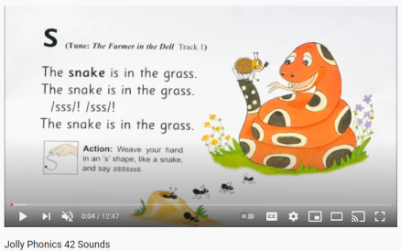  Practice the sounds you have learned on Seesaw. | Listen to a bedtime story or a story anytime! It’s valuable quality time, de-stressing and great for their reading skills to cuddle up with a family member and listen to their story.
Sounds Make Words p. 57 y sound. Check pencil grip and that they are writing the letter correctly. Some might need to trace the y at the bottom of the page (If you have a highlighter or light marker to write y yourself that’s the handiest – and they trace with pencil). | Learn letter y with the Alphablocks Magic Words: https://www.youtube.com/watch?v=3etF1Z2danw  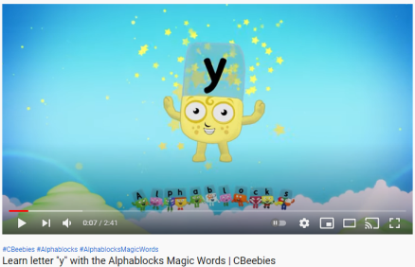 | Find items around the house beginning with y. Gather them in one spot for the week if you won’t miss them. You could add a handwritten y to the area.
Handwriting workbook y letter page. Encourage holding pencil correctly, sitting in to the table, their other hand on page, taking their time to trace the patterns carefully. Praise for good effort. | Alphablocks ck blending video - Red Level One Episode 7 'KICK': The Alphablocks have a friendly game of football. https://www.youtube.com/watch?v=pySMnVuXTj4  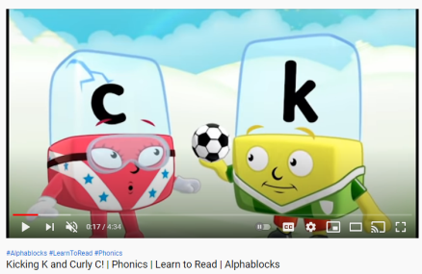 | Wellbeing -  You could do something during the day that relaxes you like Cosmic Yoga, colouring, singing, dancing, balloon breathing, etc.  At bedtime, name a few good things about your day. Maybe you had a nice dinner, or you played a game. It could be that someone did something nice for you or said something kind.
Maths –  Make the numbers 1 and 2 out of playdoh/dry cereal/pasta shapes.  Trace the numbers in sand/flour/the ground/rice/…  Practice writing numbers 1 and 2 on a page/copy.  Count 1 and 2 on your fingers. | Maths - Numberblocks - Red Level One full episodes 1-3 on Youtube: https://www.youtube.com/watch?v=fC_0LqcEsu8&list=PL9swKX1PviEpYtgsxNhSuiqvAsYhc_Uwz&index=1  (Exploring numbers 1 and 2) | Maths - Can you find things in your house that come in 2s? e.g. socks, fork and knife, …  Gather them together and sort them into their pairs. Take a photo when you are finished. Post on Seesaw
Free-writing – write anything – write letters they know, copy words from around the room/cupboards, write their own name, try writing simple words. Praise for effort and ignore mistakes in the free-writing copy. It’s all about building confidence and trying out writing and different writing genres e.g. shopping list, get well card, jokes, song lyrics, labelling drawings of toys, description of their pet, menu to play restaurant at home, etc. | Gaeilge – Folens Online. Register as a teacher of our school, using our school roll number 17796P on www.folensonline.ie/registration  Once you are logged in, type Abair Liom in the search bar and select Abair Liom A, B or C (Begin on A and work your way up). Click into the Resources for your chosen book. Under Theme select Sa Bhaile (At Home). Start on the Póstaer (Poster) activity and then any other activities listed in Sa Bhaile. Everyone can work at their own pace. Move on to Sa Bhaile B and C over the next few weeks. 10-15 mins at a time is plenty. | Gaeilge - Trying to use the language learned in Abair Liom and using general phrases throughout the week will be of most benefit. So start throwing in a few Irish words and phrases if you’re willing to give it a go!  Tar anseo! (Come here!),  Dún an doras (Close the door),  Tá an dinnéar réidh (Dinner’s ready),  Go raibh maith agat (Thank you),  Oíche mhaith & Codhladh sámh (Goodnight & sweet dreams).
Science lesson - Active Ways to Play p. 37 Edco Learning – www.edcolearning.ie
Username: edcotrial Password: edcotrial.
- Once you are logged in, select SESE in subject bar and find ‘Explore with Me 1 2019’. Click on the book image to access the digital workbook. Find Chapter 5 Play. At the top of most pages is a link button to a video/quiz/audio clip. Use these alongside the workbook pages.
- Look at page 37 of Explore with Me 1 (Infants use book online). Parent reads the dialogue between Sparky the dog and his friends:
Sparky: Hey guys, do you want to come outside and play chasing with us?
Fionn and Sandeep: No thanks!
Erin: Come on, you’ve been playing those computer games for far too long.
Sparky: Did you know that you’re supposed to get 60 minutes of physical activity every day?
Erin: Exercise is good for you. It helps your body grow bigger and stronger.
Sparky: I love when I play chasing because my heart beats quickly. Then I know that my body is working hard and I feel much better after exercising. There are lots of fun ways to exercise while you play.
- Interactive activity on www.edcolearning.ie. The children sort the images into active or inactive ways to play.
- Ask the children why they think it is important to play in an active way.
- Pupil Book, page 37: Active Ways to Play. The children identify the active ways to play; draw their favourite way to keep active; and list three reasons why it is important to keep active. Infants do this orally (speak) and draw in copy.
- Post on Seesaw.
- Think like a Scientist! Ask the children these questions:
• What does the word ’active’ mean?
• How many minutes of physical activity should we do every day?
• What happens to your heartbeat when you run really fast?
- Do something active now!
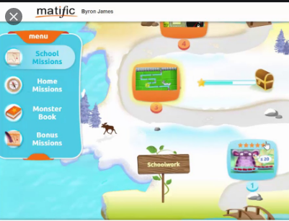
Matific

We have set up a 30 day trial of the Matific Student App. This can be played on tablet/phone/computer. It is similar to Manga High but more fun and child friendly. They can complete the games assigned and access the full course too.
I will email you your passwords separately.

Websites
Edco Learning – www.edcolearning.ie Username: edcotrial Password: edcotrial. Sign in for Readers and SESE Explore with me videos and activities.
Folens Online – www.folensonline.ie . Sign in for Readers, Irish interactive activities, and Starlight oral language posters. First register as a teacher of our school, using our school roll number 17796P on www.folensonline.ie/registration .
www.topmarks.co.uk –the children are familiar with the maths games side of this website.
www.starfall.com - Select Kindergarten for Infants. Select Grades 1, 2, 3 for 1st class. The reading activities are full access and the best place to explore.
www.oxfordowl.co.uk/user/sign_up.html - Oxford Owls e-books library - sign up for free access to high quality levelled readers.
Other Apps
Reading Eggs - you can sign up for 30 day free trial for one child per email, we have requested a school trial.
Jolly Phonics app €6.50 - suitable to guide teacher/parent through Jolly Phonics programme with child; especially beneficial for Infants, but 1st class too.

