Week 1 – 11th -15th January 2021 – 1st class
Workbooks/Table work | Online | Around the house
Sounds Make words next 2 pages  Spell It! - next week of work (2 pages) | Search for an Alphablocks video on Youtube to correspond to the sounds you are doing in your Sounds make word. Let me know which sounds you are on and I can look for you. | Listen to a bedtime story or a story anytime! It’s valuable quality time, de-stressing and great for their reading skills to cuddle up with a family member and listen to their story.
Handwriting workbook next 2 pages. Encourage holding pencil correctly, sitting in to the table, their other hand on page, taking their time to trace the patterns carefully. Praise for good effort. | Check Seesaw for new reading lists.  Read each day whether online or a real book. | Wellbeing -  You could do something during the day that relaxes you like Cosmic Yoga, colouring, singing, dancing, balloon breathing, etc.  At bedtime, name a few good things about your day. Maybe you had a nice dinner, or you played a game. It could be that someone did something nice for you or said something kind.
Mental Maths – next week of work (2 pages)  Maths book – skip to p62-63 Operations (adding and taking away) | Numberblocks Level 3 all the best 11-20 moments playlist –  https://www.youtube.com/playlist?list=PL9swKX1PviErYL6fIgGtuuOonwQwoEusD  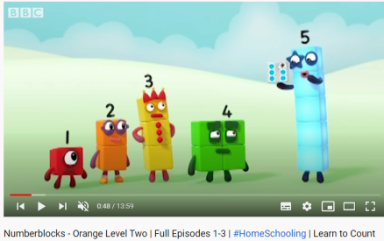  Have a look at a few of the videos on this playlist to revise numbers 11-20. | Play any maths/board games you might have at home like Snakes and Ladders, Monopoly, card games, etc.
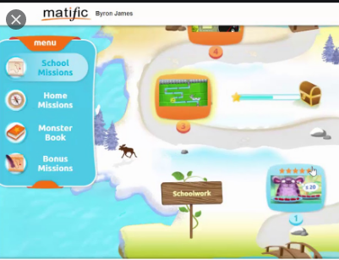
Matific

We have set up a 30 day trial of the Matific Student App. This can be played on tablet/phone/computer. It is similar to Manga High but more fun and child friendly. They can complete the games assigned and access the full course too. I will email you your passwords separately.
Gaeilge – Folens Online. Register as a teacher of our school, using our school roll number 17796P on www.folensonline.ie/registration. Once you are logged in, type Abair Liom in the search bar and select Abair Liom A, B, C or D (Begin on A and work your way up). Click into the Resources for your chosen book. Under Theme select Sa Bhaile (At Home). Start on the Póstaer (Poster) activity and then any other activities listed in Sa Bhaile. Everyone can work at their own pace. Move on to Sa Bhaile B and C (and D 1st/2nd class) over the next few weeks. 10-15 mins at a time is plenty.
Trying to use the language learned in that time and general phrases throughout the week will be of most benefit. So start throwing in a few Irish words and phrases if you’re willing to give it a go!
Tar anseo! (Come here!), Dún an doras (Close the door),
Tá an dinnéar réidh (Dinner’s ready), Go raibh maith agat (Thank you),
Oíche mhaith & Codhladh sámh (Goodnight & sweet dreams).
Science lesson - Active Ways to Play p. 37 - Edco Learning - www.edcolearning.ie
Username: edcotrial Password: edcotrial.
- Once you are logged in, select SESE in subject bar and find ‘Explore with Me 1 2019’. Click on the book image to access the digital workbook. Find Chapter 5 Play. At the top of most pages is a link button to a video/quiz/audio clip. Use these alongside the workbook pages.
- Look at page 37 of Explore with Me 1 (www.edcolearning.ie Infants). Parent reads the dialogue between Sparky and his friends:
Sparky: Hey guys, do you want to come outside and play chasing with us?
Fionn and Sandeep: No thanks!
Erin: Come on, you’ve been playing those computer games for far too long.
Sparky: Did you know that you’re supposed to get 60 minutes of physical activity every day?
Erin: Exercise is good for you. It helps your body grow bigger and stronger.
Sparky: I love when I play chasing because my heart beats quickly. Then I know that my body is working hard and I feel much better after exercising. There are lots of fun ways to exercise while you play.
- Interactive activity on www.edcolearning.ie. The children sort the images into active or inactive ways to play.
- Ask the children why they think it is important to play in an active way.
- Pupil Book, page 37: Active Ways to Play. The children identify the active ways to play; draw their favourite way to keep active; and list three reasons why it is important to keep active. Infants do this orally (speak) and draw.
- Post on Seesaw.
- Think like a Scientist! Ask the children these questions:
• What does the word ’active’ mean?
• How many minutes of physical activity should we do every day?
• What happens to your heartbeat when you run really fast?
- Do something active now!
Readers – read each day
- Read aloud to your parent readers on www.folensonline.ie . Search ‘Reading Zone’ and select the right class level. There are several readers for each class group. If these books don’t suit your child try an easier/harder level, or if they just don’t like the style of book try out the readers on edcolearning or another source.
- Read aloud to your parent readers on www.edcolearning.ie . Username: edcotrial Password: edcotrial. Search for reader. Click Fit on Screen (bottom right) to enlarge page.
Senior Infants readers - Oh no, Zeb 2012 Book 1 & Danny to the Rescue 2012
1st class reading collection (Book 1) - Pirate Pat and more…
1st class reading collection (Book 2) - Sleep Tight and more…
1st/2nd class novel (Novel 1) - Jasper Saves the Day 2012
2nd class novel (Novel 2) - Jasper Goes on Holiday 2012
- Choose shorter books like we have at school on Oxford Owls e-books library - sign up for free access to high quality levelled readers www.oxfordowl.co.uk/user/sign_up.html

Websites
Edco Learning – www.edcolearning.ie Username: edcotrial Password: edcotrial. Sign in for Readers and SESE Explore with me videos and activities.
Folens Online – www.folensonline.ie . Sign in for Readers, Irish interactive activities, and Starlight oral language posters. First register as a teacher of our school, using our school roll number 17796P on www.folensonline.ie/registration .
www.topmarks.co.uk –the children are familiar with the maths games side of this website.
www.starfall.com - Select Kindergarten for Infants. Select Grades 1, 2, 3 for 1st class. The reading activities are full access and the best place to explore.
www.oxfordowl.co.uk/user/sign_up.html - Oxford Owls e-books library - sign up for free access to high quality levelled readers.
Other Apps
Reading Eggs - you can sign up for 30 day free trial for one child per email, we have requested a school trial.
Jolly Phonics app €6.50 - suitable to guide teacher/parent through Jolly Phonics programme with child; especially beneficial for Infants, but 1st class too.

